Question 1:
Create a NumPy array containing the integers from 1 to 20. Perform the following operations:
- Display the array.
- Find the shape of the array.
- Find the maximum and minimum values.
- Calculate the mean and standard deviation.
- Reshape the array into a 4 × 5 matrix.
- Display the second row of the matrix.
- Display the third column of the matrix.

CODE:

import numpy as np

arr = np.arange(1,21)
print(arr)
print(arr.shape)
print(arr.max())
print(arr.min())
print(arr.mean())
print(arr.std())

matrix = arr.reshape(4,5)
print(matrix)
print(matrix[1])
print(matrix[:, 2])

OUTPUT:

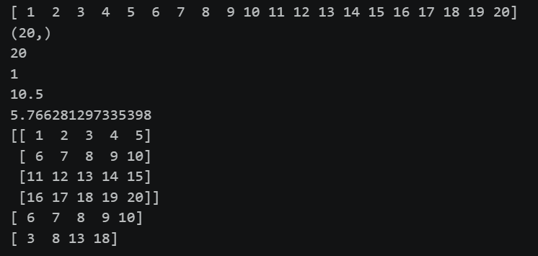

Question 2:
Create two NumPy arrays:
A = [10, 20, 30, 40, 50]
B = [5, 10, 15, 20, 25]
Perform:
- Addition of A and B.
- Subtraction of B from A.
- Element-wise multiplication.
- Element-wise division.
- Find the sum of all elements in A.

CODE:
import numpy as np

A = np.array([10, 20, 30, 40, 50])
B = np.array([5, 10, 15, 20, 25])

print(A+B)
print(A-B)
print(A*B)
print(A/B)
print(A.sum())

OUTPUT:
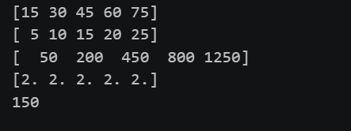

Question 3:
Create a DataFrame using the following student data:

Roll No | Name | Marks
101 | Ravi | 85
102 | Priya | 92
103 | Kiran | 78
104 | Anu | 88
105 | Sita | 95

Perform the following operations:
- Display the DataFrame.
- Display the first three records.
- Find the average marks.
- Find the student with the highest marks.
- Find the student with the lowest marks.
- Add a new column called "Grade" using:
  - A for Marks ≥ 90
  - B for Marks between 80 and 89
  - C for Marks < 80
CODE:

import pandas as pd

data = {
'RollNo' : [101, 102, 103, 104, 105],
'Names' : ["Ravi", "Priya", "Kiran", "Anu", "Sita"],
'Marks' : [85, 92, 78, 88, 95]
}

Table = pd.DataFrame(data)

print(Table)
print("\nFirst three rows: \n", Table.head(3))
print("\nAverage marks: ", Table['Marks'].mean())

print("\nHighest Marks: ")
print(Table.loc[[Table['Marks'].idxmax()], ["Names", "Marks"]])

print("\nLowest Marks: ")
print(Table.loc[[Table['Marks'].idxmin()], ["Names", "Marks"]])

def grade(Marks):

if Marks >= 90:
return 'A'
elif 80 <= Marks <= 89:
return 'B'
else:
return 'C'

Table['Grade'] = Table['Marks'].apply(grade)

print("\n New Table: \n", Table)

OUTPUT:

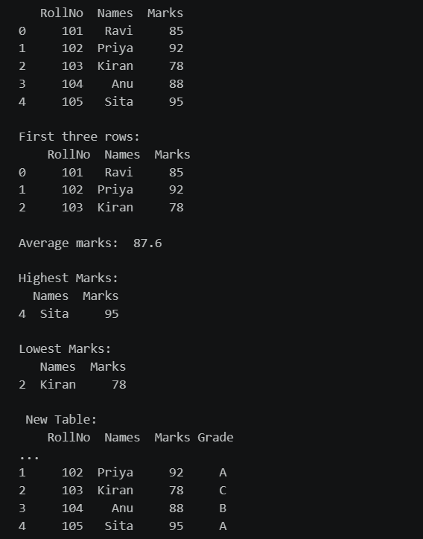

Question 4:
Create a DataFrame containing the following information:

Product | Price | Quantity
Laptop | 50000 | 10
Mouse | 500 | 50
Keyboard | 1200 | 30
Monitor | 10000 | 15

Perform:
- Calculate the total value of each product using: Total Value = Price × Quantity
- Add the Total Value column.
- Find the product with the highest total value.
- Calculate the overall inventory value.

CODE:

import pandas as pd

data = {
'Product' : ["Laptop", "Mouse", "Keyboard", "Monitor"],
'Price' : [500000, 500, 1200, 100000],
'Quality' : [10, 50, 30, 15]
}

Table = pd.DataFrame(data)

print("original table: \n", Table)

Table['Total Value'] = Table['Price'] * Table['Quality']

print("\n Table with total values:\n ", Table)

print("\nProduct with highest total value: ")
print(Table.loc[[Table['Total Value'].idxmax()], ["Product", "Total Value"]])

overallvalue = Table['Total Value'].sum()

print("\nOverall value: \n ", overallvalue)

OUTPUT:

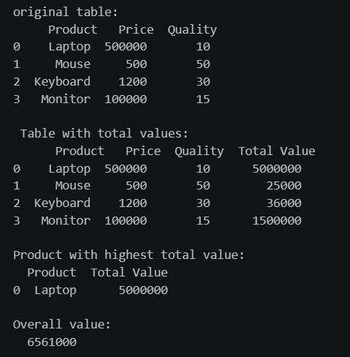

Question 5:
Download the Iris dataset from Scikit-learn and perform the following:
- Load the dataset into a Pandas DataFrame.
- Display the first five records.
- Find the number of rows and columns.
- Display column names.
- Check for missing values.
- Generate summary statistics using describe().
- Find the number of samples belonging to each class.

CODE:

from sklearn.datasets import load_iris
import pandas as pd

iris = load_iris()
df = pd.DataFrame(iris.data, columns=iris.feature_names)
df["target"] = iris.target

print(df.head())
print("shape:", df.shape)
print(df.columns)
print(df.isnull().sum())
print(df.describe())
print(df["target"].value_counts())

OUTPUT:

